Competitive Factors of St. Cloud for Businesses

in Comparison with Comparable Upper Midwest Cities

Haneum Claude Lee and Hyesu Lee

St. Cloud State University

Professor Soumare

May 10, 2021

# **Table of Contents**

**Table of Contents** 2

**Executive Summary** 4

**Data Summary** 6

- American Community Survey from Integrated Public Use Microdata Series (IPUMS) 6

- Local Area Unemployment Statistics (LAUS) 6

- Occupational Employment and Wage Statistics (OEWS) 6

**Study Design and Analysis Plan** 8

- IPUMS and LAUS 8

o IPUMS Variable Selection 8

o One-Way ANOVA 8

o Summary Table 9

- OEWS 11

o Occupation Selection 11

o Variable Selection 12

o Wilcoxon Signed-Rank Test 12

o Summary Table 13

**Findings** 14

- Demographic & Economic characteristics 14

o Demographic 14

o Economic 18

o Summary 19

- Occupations 20

o Major class 20

o Subclass 26

o Summary 31

**Conclusion** 32

**Limitations** 33

**Future work** 34

**Appendix** 35

- **Appendix A**: Chosen Variables 35

- **Appendix B**: Full Testing Results 36

o IPUMS **Error! Bookmark not defined.**

o LAUS **Error! Bookmark not defined.**

o OEWS **Error! Bookmark not defined.**

**References** 37

# **Executive Summary**

The City of St. Cloud Economic Development Authority (EDA) assists small and large business in St. Cloud as well as city development and permit process. The office is dedicated to enhancing St. Cloud’s economic vitality and expanding the city’s tax and employment base by making business reports and strategic plans for the city.

One of the EDA’s economic development goals includes attracting, retaining, and growing business through branding and marketing. To help EDA achieve this goal, the project was set up to provide statistical evidence of competitive factors of St. Cloud for business establishments in comparison to other comparable Upper Midwest cities. The cities include:

Minnesota: Rochester, Duluth, Mankato North Dakota: Fargo, Grand Forks

Wisconsin: Eau Claire, La Crosse Iowa: Dubuque, Cedar Rapids

By identifying which factors of St. Cloud are competitive compared to these nine cities, EDA will have better understanding of how to market and brand St. Cloud for business establishments.

The project focuses on two main research question as stated below:

1. Does St. Cloud offer better demographic or economic advantage for businesses compared to similar Upper Midwest cities?
2. What are some occupation that present unique characteristics in St. Cloud compared to similar Upper Midwest cities?

To be able to compare between these 10 cities, it requires that the data have some sort of classification on geographical city area. Based on its availability, three data sets were obtained: American Community Survey from Integrated Public Use Microdata Series (IPUMS), Local Area Unemployment Statistics (LAUS), and Occupational Employment and Wage Statistics (OEWS). Each data set specifies its observations into either county level using Public Use Microdata Area (PUMA) or Metropolitan Statistical Area (MSA).

After the datasets were obtained, descriptive analysis was performed in each variable. Based on the analysis, the relevance and significance of those variables to the project was determined. Among the relevant and significant variables, statistical testing, either ANOVA or Wilcoxon Sign-Rank test, was performed to identify which factors are considered statistically significant. Once identifying all statistically significant factors, appropriate descriptions and practical significance were reported.

Below are some of the most interesting and unique insights that were obtained from the analysis. Among those 10 Upper Midwest cities, St. Cloud has:

* High family size with the lowest population age and low college education attainment.
* High house and mortgage values but log rent.
* The highest travel time to work.
* The highest unemployment rates.
* Low number with high wage jobs in protective services, community and social services, food preparation and servicing related, and landscaping and groundskeeping workers.
* Sharp increase in number of jobs in architecture and engineering, but with low wage.
* High number of jobs in industrial manual labors, specifically in construction and extractions, production, transportation and material moving.

# **Data Summary**

Three datasets were used in this project. Each dataset has different characteristics that require different statistical approach.

* American Community Survey from Integrated Public Use Microdata Series (IPUMS)

IPUMS data contains wide range of demographic data that were collected via American Community Survey. Based on the nature characteristics of variable, each variable’s unit is determined into either household or person. The data includes surveys from 2012 to 2019. Since the data unit is household/person, Public Use Microdata Area (PUMA) classification was used to approximate city areas for the 10 cities. PUMA generally uses county as its baseline. Variables are chosen from the dataset based on some criteria, and they are listed in Appendix A.

* Local Area Unemployment Statistics (LAUS)

LAUS data contains four economic indicator variables: Civil Labor Force, Employment, Unemployment, and Unemployment rate. All variable except Unemployment were chosen in the analysis. This data includes values from 1990 to 2020, but to be consistent with IPUMS, only 2012-2020 data were extracted. The data is recorded monthly (seasonally adjusted) with each unit as one Metropolitan Statistical Area (MSA).

* Occupational Employment and Wage Statistics (OEWS)

OEWS data contains number of employment and average wage information of occupations in each city. The data is collected yearly on May, and each unit is a occupation class of one MSA. To be consistent with IPUMS and LAUS, only 2012-2020 values were extracted. Note that there are two levels of occupation classification: major areas, which classifies all occupations into 22 classes, then detailed areas, which are subclass of each major areas. The analysis was done on all major areas and some detailed areas based on some criteria. Note that the wage information has upper limit cutoff. The details are in Analysis Plan.

# **Study Design and Analysis Plan**

Since the goal of the project is compare 10 cities cross-sectionally, the first step of analysis was to find dataset that has geographic classification that can be used to classify each data point into one of the 10 cities. Accordingly, IPUMS, LAUS, and OEWS were chosen as they have city area classification and also provide information that are relevant to the goal of the project. In this study, only the results of significant variables were reported. The full testing results are presented in Appendix B.

* IPUMS and LAUS
  + IPUMS Variable Selection

IPUMS data contains wide range of variables, therefore descriptive analysis was performed to distinguish what variables to focus on. The variables are chosen based on its relevance to the study, its practical significance, and its structure. In other words, the variables need to be related to the study, have any meaning in the context, and can be easily handled and interpreted in the analysis process.

* + One-Way ANOVA

With the chosen variables from IPUMS, One-Way Analysis of Variance (ANOVA) method was used to test for any significance. ANOVA compares means with respect to their variance to test if there is a statistically significant difference between the groups. For IPUMS, the means are the average value of the given variation of the sample in each city, where the group is city and the variation is sample population. The comparison was done for each year, and for the simplicity, it was only done for years 2017-2019.

Within ANOVA, multiple comparisons method was implemented to detect which city is significantly different from St. Cloud rather than comparing all 10 cities at the same time. Multiple comparison has different methods based on the variance size of each group. Levene’s test for equal variance was performed on each pair of each year to determine if the pair has equal variance or unequal variance, and then appropriate method was applied for each case. For equal variance case, Tukey’s Honest Significant Difference (HSD) was used, whereas for unequal variance case, Dunnett’s Modified Tukey-Kramer Pairwise Multiple Comparison (DTK) was applied. Note that HSD uses conservative error rate compared to DTK.

For LAUS data, civilian labor force, total employment, and unemployment rate were chosen. Same testing method was applied as IPUMS data, but for LAUS, seasonally adjusted monthly variation was used for the group variance. The testing was done on years 2017-2020.

HSD and DTK have advantage of specifying the direction of the difference. In other words, the testing can tell whether one group is greater/less than the other group rather than just detecting any difference. Appropriate direction was specified based on the result.

* + Summary Table

Once the significant pairs are obtained, the results were summarized into a table for each variable. The table 1 below is one from Average First Mortgage Payment:

|  |  |  |  |
| --- | --- | --- | --- |
| **(DTK)** | 2017 | 2018 | 2019 |
| **Rochester, MN** | **+1\*** | **+1\*** | **+1\*** |
| **Fargo, ND** | **+2\*** | **+2\*** | **+2\*** |
| **Grand Forks, ND** | **-9\*** | **-5\*** | **-3\*** |
| **Duluth, MN** | **-6\*** | **-6\*** | **-4\*** |
| **Cedar Rapids, IA** | **-5\*** | **-4\*** | **-5\*** |
| La Crosse, WI | +3* | -7* | -6* |
| Eau Claire, WI | -7* | -8* | -7* |
| Mankato, MN | +4 | -3 | -8* |
| **Dubuque, IA** | **-8\*** | **-9\*** | **-9\*** |

Table 1

Each row shows the comparison between the city and St. Cloud. The rows are ordered by the difference in means of 2019 in descending order; that is, if the city has higher mean than St. Cloud, than it will be ordered on the top, and vice versa.

Number in each cell represents the ranking of the mean difference, so the city with the highest mean has ranking 1 and the lowest mean has ranking 9. In this case, Rochester, MN has the highest mean in all three years, hence has 1’s in each column.

The signs in front of the numbers represent whether the difference was positive or negative. So, positive difference means that the city had higher mean than St. Cloud, and vice versa. Logically, the higher ranking generally have positive signs and placed on the top of tables.

The asterisk by the ranking represents that the multiple comparison testing result shows that the difference was significant. The testing method is specified on the left top corner. For this variable, DTK was used.

If the difference was significant and the difference was positive, then the cell was light-shaded, and if the difference was significant and the difference was negative, then the cell was dark-shaded. If each row showed consistent coloring, then the row was bolded, which can be interpreted that the city is significantly greater/less than St. Cloud for the past couple years.

Based on the number of bolded rows and proportion of shading, the variable’s characteristics were described. For example, for average first mortgage payment, there are much more dark-shaded bolded rows than light-shaded rows. Therefore, it can be concluded that St. Cloud has one of the highest average first mortgage payment.

* OEWS
  + Occupation Selection

All major classifications are considered. Among subclassification, the following criteria was implemented to determine its relevance to the study: quotient of job ratio of St. Cloud over the ratio of all US cities is greater than the upper quartile or less than the lower quartile for all testing years with at least 0.1% of total employment in St. Cloud. The quartiles are extracted from the distribution of quotients in all cities of all testing years. The contextual meaning of criteria is occupations whose job ratio in the area is either much higher or much less than average US ratio. The total employment condition was added to prevent any outliers resulting from too small of sample size.

* + Variable Selection

Since there are already many occupations to compare, only job ratio and average annual mean wage were considered. The upper limit for annual mean wage is $187,200 for 2012-2015, and $208,000 for years after 2015. For simplicity, those datapoints above these limits are entered as the limit value, which may have biased the data.

* + Wilcoxon Signed-Rank Test

Unlike IPUMS or LAUS, OEWS has its unit as one occupation per one city per year. Due to its structure, there is no mean with variation to apply ANOVA. Instead, Wilcoxon Signed-Rank test is applied to compare whether the median of job ratio and wage of 10 cities equal to the one of St. Cloud, and was done on years 2017-2020.

Wilcoxon Signed-Rank test is used to compare if the median value of sample differs from a specified median value using the signs and ranking of the sample obtained from the difference between the data and the specified mean value as its variance. In this context, if the test result shows a significant difference, it can be interpreted as that St. Cloud has significantly different job ratio or wage in the given occupation compared to the average of the 10 Upper Midwest cities.

For this testing, the direction of difference was not considered. Therefore, the difference was conjectured from the line graph of the cities. If there is a significant difference for all years and the graph indicate that St. Cloud values are lower than other cities, then it can be interpreted as “St. Cloud has significantly lower value than other 9 cities for the past 4 years.”

* + Summary Table

The summary table includes its p-value from Wilcoxon Signed-Rank test for both job ratio and wage in 4 years. The shading represents that the difference was significant with 95% confidence level. So, the more shaded cells there are, the more evidence of the difference there are.

Table 2 and Figure 1 and 2 below are results from Architecture and Engineering.

|  |  |  |  |  |
| --- | --- | --- | --- | --- |
|  | 2017 | 2018 | 2019 | 2020 |
| Ratio | 0.01562 | 0.01562 | 0.04688 | 0.125 |
| Wage | 0.01562 | 0.03125 | 0.01562 | 0.03125 |

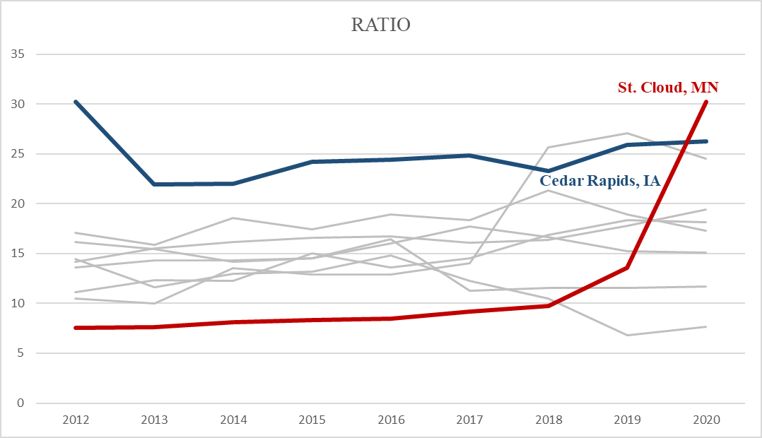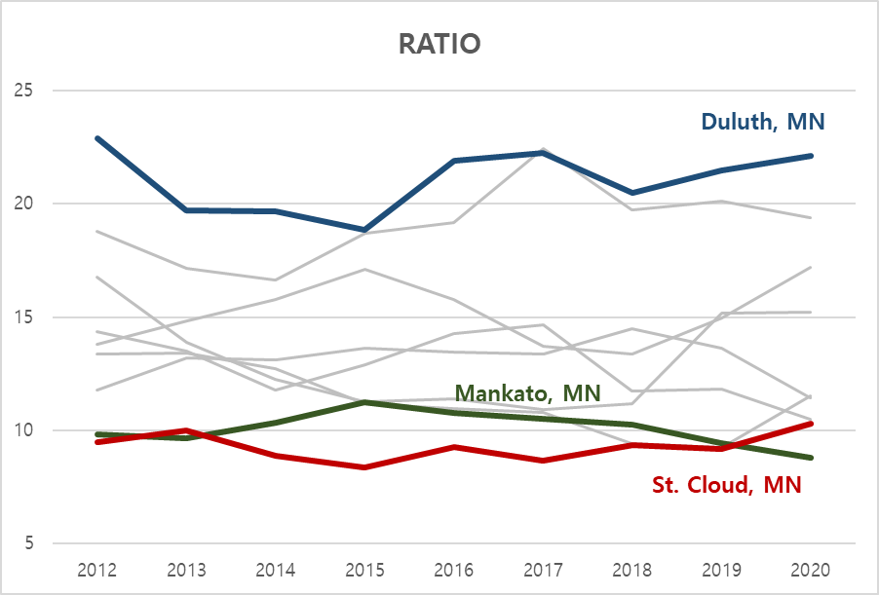Table 2

Figure 1

Figure 2

Since both rows are mostly shaded, there is evidence for significant difference for both ratio and wage. In figure 1, St. Cloud has one of the lowest values in ratio and in figure 2, it has the highest values in wage. Therefore, it can be concluded that the ratio of architecture and engineering occupations in St. Cloud are significantly lower from 9 other cities, whereas its wage is significantly higher.

# **Findings**

* Demographic & Economic characteristics
  + Demographic

The significant factors are: first mortgage payment, gross rent, family size, travel time to work, house values, age, and proportion of finished some college.

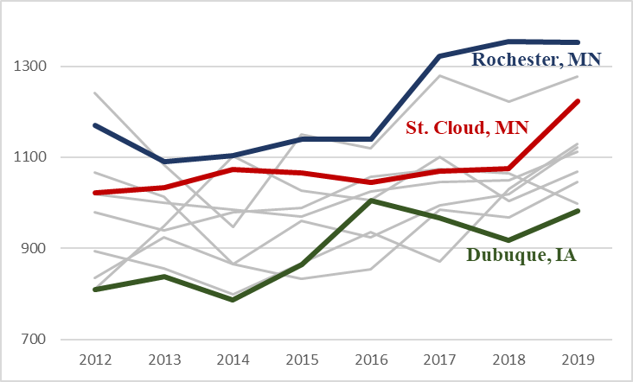Average First Mortgage Payment

|  |  |  |  |
| --- | --- | --- | --- |
| **(DTK)** | 2017 | 2018 | 2019 |
| **Rochester, MN** | **+1\*** | **+1\*** | **+1\*** |
| **Fargo, ND** | **+2\*** | **+2\*** | **+2\*** |
| **Grand Forks, ND** | **-9\*** | **-5\*** | **-3\*** |
| **Duluth, MN** | **-6\*** | **-6\*** | **-4\*** |
| **Cedar Rapids, IA** | **-5\*** | **-4\*** | **-5\*** |
| La Crosse, WI | +3* | -7* | -6* |
| Eau Claire, WI | -7* | -8* | -7* |
| Mankato, MN | +4 | -3 | -8* |
| **Dubuque, IA** | **-8\*** | **-9\*** | **-9\*** |

Table 3

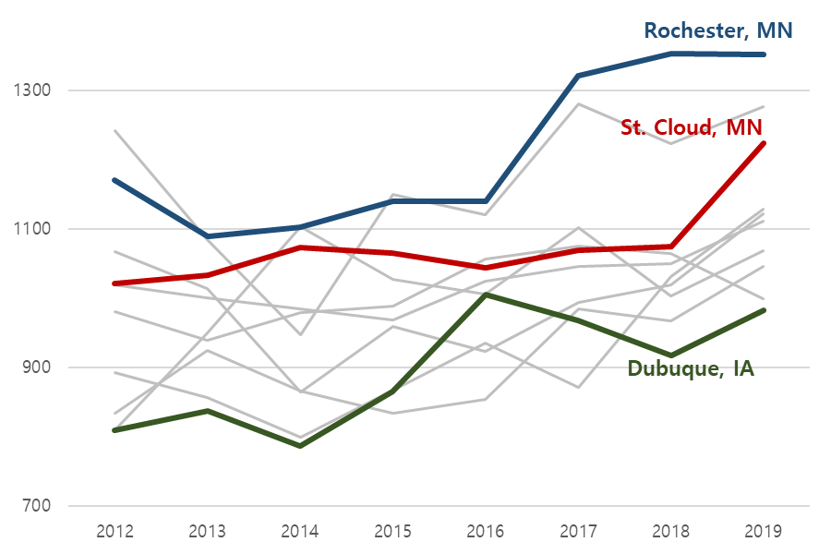

Figure 3

St. Cloud has one of the highest average first mortgage payment since it is significantly greater than the most cities. It is significantly lower than Rochester, MN and Fargo, ND.

|  |  |  |  |
| --- | --- | --- | --- |
| **(DTK)** | 2017 | 2018 | 2019 |
| **Duluth, MN** | **+3\*** | **+3\*** | **+1\*** |
| **Rochester, MN** | **+1\*** | **+1\*** | **+2\*** |
| Mankato, MN | +2* | +5* | +3 |
| **Fargo, ND** | **+5\*** | **+7\*** | **+4\*** |
| Grand Forks, ND | -9* | +4* | +5 |
| La Crosse, WI | +4* | +2* | -6 |
| Eau Claire, WI | -8 | +6* | -7* |
| Cedar Rapids, IA | +7* | -9* | -8* |
| Dubuque, IA | +6* | -8* | -9* |

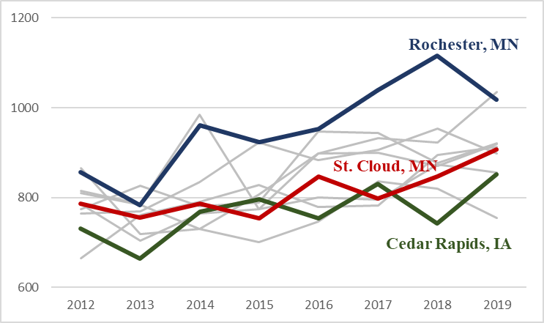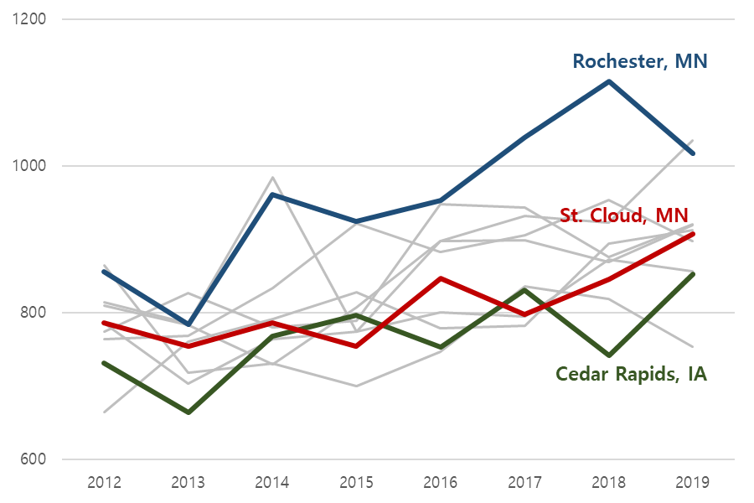Average Gross Rent

Figure 4

Table 4

St. Cloud has low to average of average gross rent since it is significantly less than three cities but not greater than most cities.

|  |  |  |  |
| --- | --- | --- | --- |
| **(HSD)** | 2017 | 2018 | 2019 |
| Rochester, MN | +1 | -2 | -1 |
| Cedar Rapids, IA | +4 | -4 | -2 |
| Dubuque, IA | +2 | -1 | -3 |
| Eau Claire, WI | -5 | -6 | -4 |
| Mankato, MN | -7 | -5 | -5 |
| **Grand Forks, ND** | **-8\*** | **-8\*** | **-6\*** |
| Fargo, ND | +3 | -3 | **-7\*** |
| La Crosse, WI | -6 | -7 | **-8\*** |
| **Duluth, MN** | **-9\*** | **-9\*** | **-9\*** |

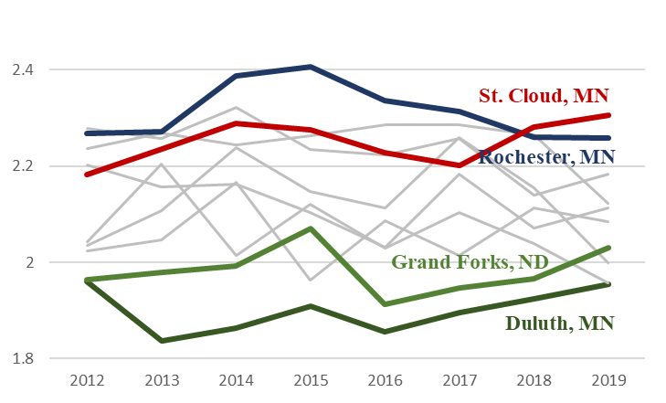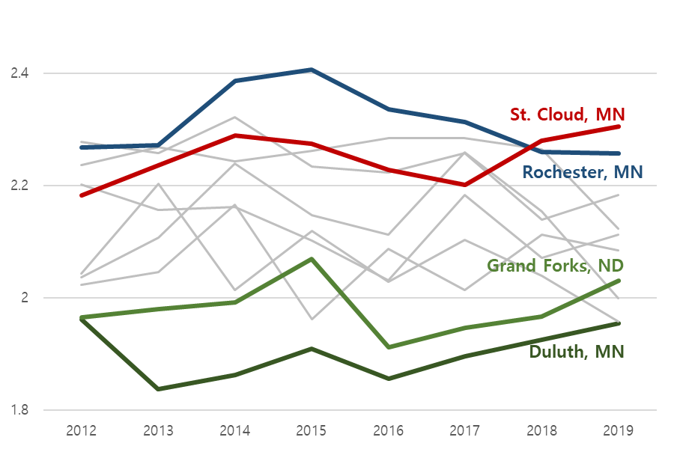Average Family Size

Table 5

Figure 5

St. Cloud has high to average of average family size since it is significantly greater than Grand Forks, ND and Duluth, MN, but not less than most cities.

|  |  |  |  |
| --- | --- | --- | --- |
| **(DTK)** | 2017 | 2018 | 2019 |
| **Cedar Rapids, IA** | **-5\*** | **-6\*** | **-1\*** |
| **Dubuque, IA** | **-3\*** | **-1\*** | **-2\*** |
| **Eau Claire, WI** | **-4\*** | **-2\*** | **-3\*** |
| **Rochester, MN** | **-6\*** | **-3\*** | **-4\*** |
| **Fargo, ND** | **-8\*** | **-9\*** | **-5\*** |
| **La Crosse, WI** | **-7\*** | **-7\*** | **-6\*** |
| **Mankato, MN** | **-1\*** | **-4\*** | **-7\*** |
| **Duluth, MN** | **-2\*** | **-5\*** | **-8\*** |
| **Grand Forks, ND** | **-9\*** | **-8\*** | **-9\*** |

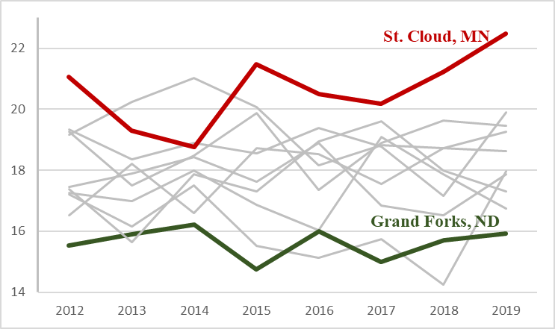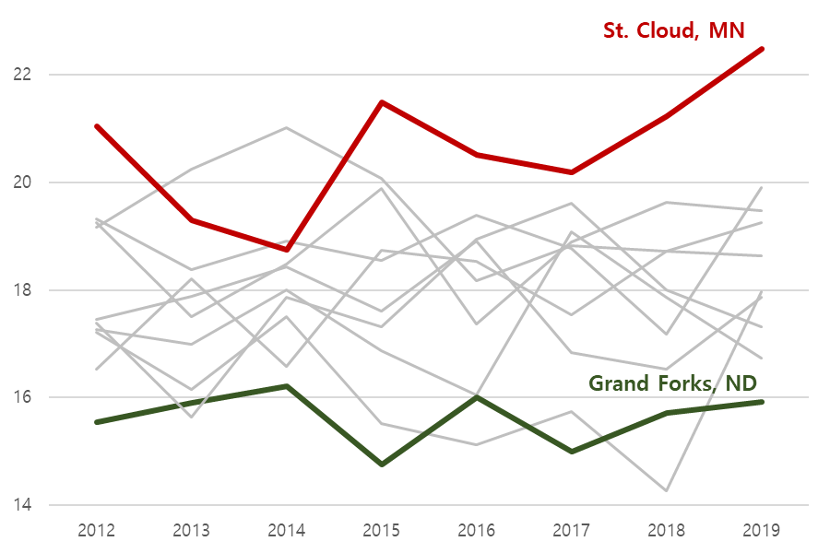Average Travel Time to Work

Figure 6

Table 6

St. Cloud has the highest average travel time to work since it is significantly great than all cities.

|  |  |  |  |
| --- | --- | --- | --- |
| **(DTK)** | 2017 | 2018 | 2019 |
| **Rochester, MN** | **+1\*** | **+1\*** | **+1\*** |
| **Fargo, ND** | **+2\*** | **+2\*** | **+2\*** |
| **Eau Claire, WI** | **-5\*** | **-5\*** | **-3\*** |
| La Crosse, WI | -3 | -4* | -4* |
| **Duluth, MN** | **-6\*** | **-3\*** | **-5\*** |
| **Mankato, MN** | **-4\*** | **-7\*** | **-6\*** |
| **Cedar Rapids, IA** | **-8\*** | **-9\*** | **-7\*** |
| **Grand Forks, ND** | **-9\*** | **-8\*** | **-8\*** |
| **Dubuque, IA** | **-7\*** | **-6\*** | **-9\*** |

Average House Values

Table 7

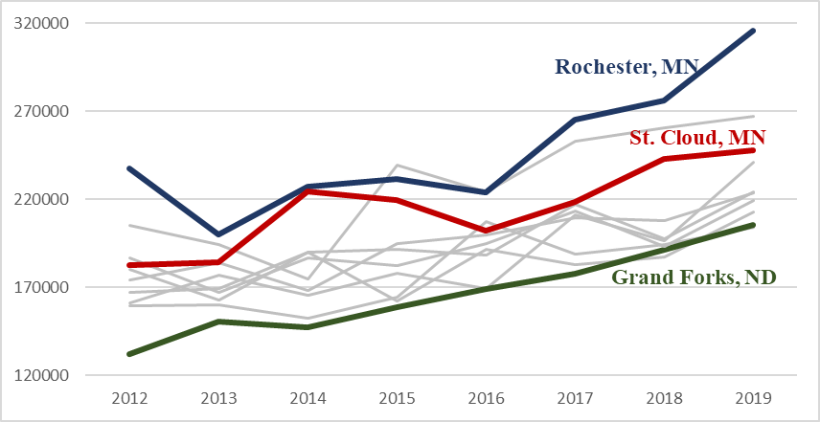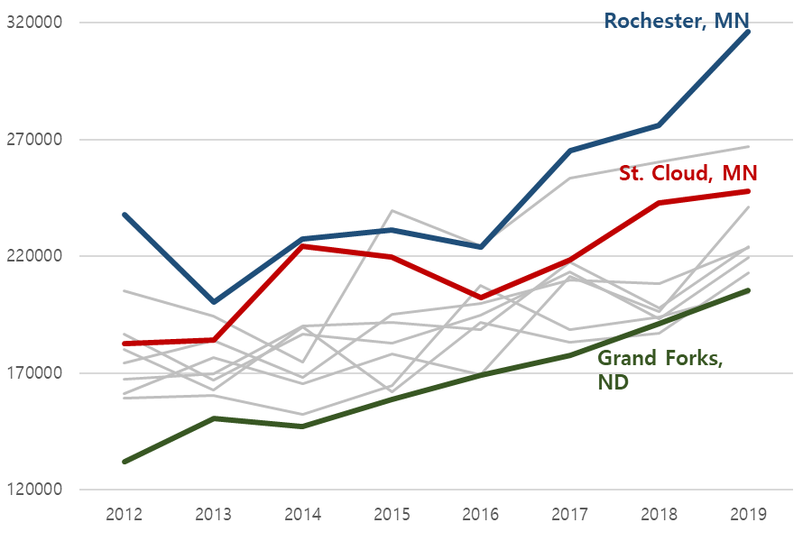

Figure 7

St. Cloud has one of the highest average house values since it is significantly greater than most cities. It is significantly less than Rochester, MN and Fargo, ND.

|  |  |  |  |
| --- | --- | --- | --- |
| **(DTK)** | 2017 | 2018 | 2019 |
| **Dubuque, IA** | **+1\*** | **+1\*** | **+1\*** |
| **Rochester, MN** | **+4\*** | **+5\*** | **+2\*** |
| **Cedar Rapids, IA** | **+5\*** | **+4\*** | **+3\*** |
| **Duluth, MN** | **+7\*** | **+2\*** | **+4\*** |
| **Eau Claire, WI** | **+2\*** | **+3\*** | **+5\*** |
| **La Crosse, WI** | **+3\*** | **+6\*** | **+6\*** |
| **Grand Forks, ND** | **+6\*** | **+7\*** | **+7\*** |
| Mankato, MN | -8 | -8 | +8 |
| **Fargo, ND** | **-9\*** | **-9\*** | **-9\*** |

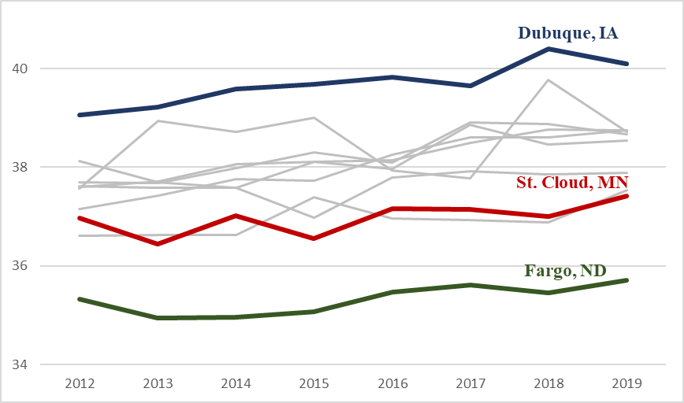Average Population Age

Table 8

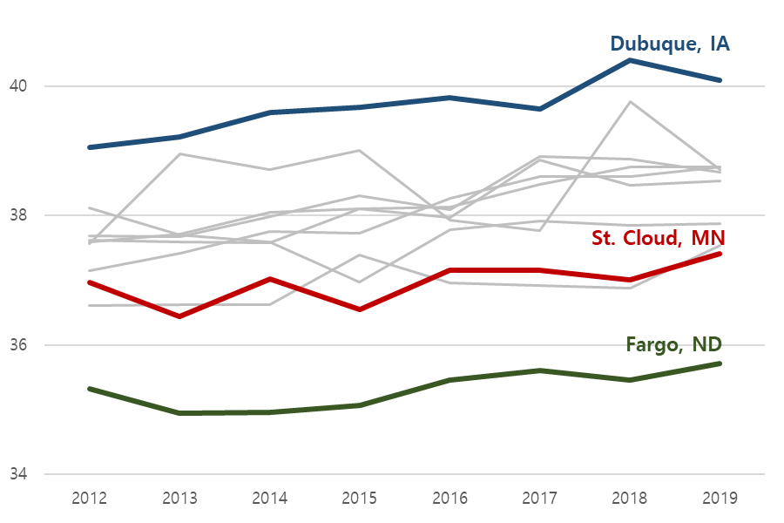

Figure 8

St. Cloud has one of the lowest average population age as it is significantly less than the most cities. It is significantly great than Fargo, ND.

|  |  |  |  |
| --- | --- | --- | --- |
| **(DTK)** | 2017 | 2018 | 2019 |
| **Duluth, MN** | **+1\*** | **+3\*** | **+1\*** |
| **Rochester, MN** | **+3\*** | **+1\*** | **+2\*** |
| **Fargo, ND** | **+2\*** | **+2\*** | **+3\*** |
| Grand Forks, ND | +5 | +6* | +4* |
| **Mankato, MN** | **+4\*** | **+4\*** | **+5\*** |
| **La Crosse, WI** | **-6\*** | **+5\*** | **+6\*** |
| Cedar Rapids, IA | -8* | -7 | +7* |
| **Eau Claire, WI** | **-7\*** | **-8\*** | **+8\*** |
| **Dubuque, IA** | **-9\*** | **-9\*** | **-9\*** |

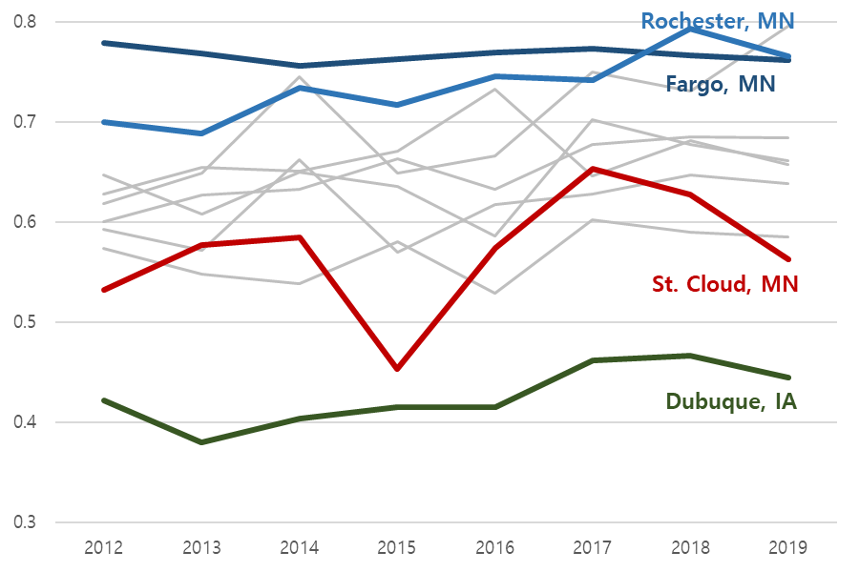Proportion of Finished Some College

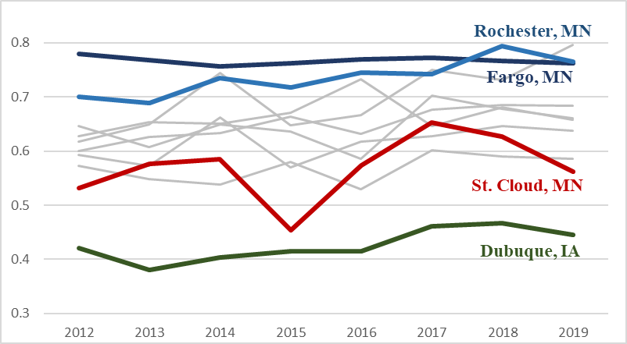

Table 9

Figure 9

St. Cloud has one of the lowest proportion of population that finished some college since it is significantly less than most of the cities. It is significantly greater than Dubuque, IA.

* + Economic

|  |  |  |  |
| --- | --- | --- | --- |
| **(DTK)** | 2017 | 2018 | 2019 |
| **Cedar Rapids, IA** | **+2\*** | **+1\*** | **+1\*** |
| **Duluth, MN** | **+1\*** | **+2\*** | **+2\*** |
| **Fargo, ND** | **+3\*** | **+3\*** | **+3\*** |
| **Rochester, MN** | **+4\*** | **+4\*** | **+4\*** |
| **Eau Claire, WI** | **-5\*** | **-5\*** | **-5\*** |
| **La Crosse, WI** | **-6\*** | **-6\*** | **-6\*** |
| **Mankato, MN** | **-7\*** | **-7\*** | **-7\*** |
| **Dubuque, IA** | **-9\*** | **-8\*** | **-8\*** |
| **Grand Forks, ND** | **-8\*** | **-9\*** | **-9\*** |

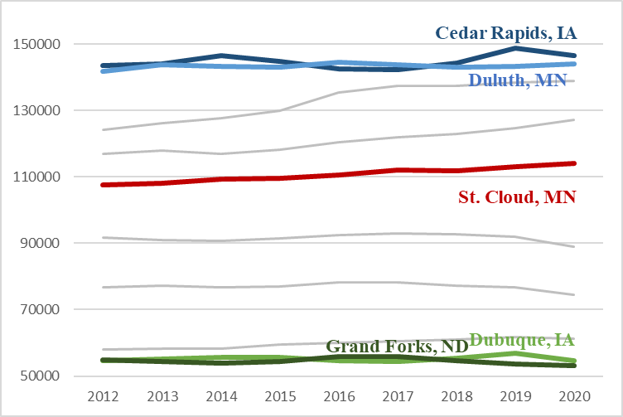Civilian Labor Force Participation

Table 10

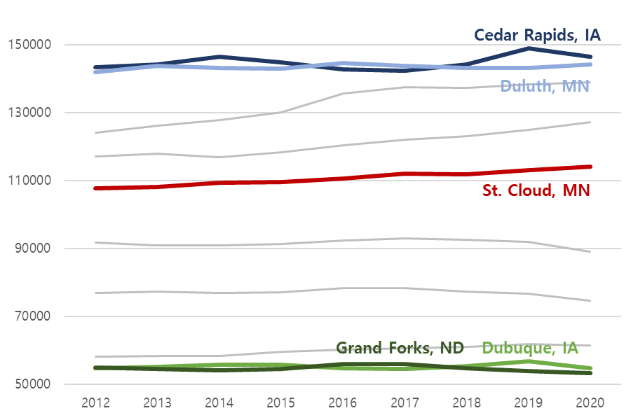

Figure 10

The civilian labor force participation of St. Cloud is around the average since the number of significantly greater cities are about the same as the number of significantly less cities.

|  |  |  |  |
| --- | --- | --- | --- |
| **(DTK)** | 2017 | 2018 | 2019 |
| **Fargo, ND** | **+3\*** | **+3\*** | **+3\*** |
| **Cedar Rapids, IA** | **+2\*** | **+1\*** | **+1\*** |
| **Duluth, MN** | **+1\*** | **+2\*** | **+2\*** |
| **Rochester, MN** | **+4\*** | **+4\*** | **+4\*** |
| **Eau Claire, WI** | **-5\*** | **-5\*** | **-5\*** |
| **La Crosse, WI** | **-6\*** | **-6\*** | **-6\*** |
| **Mankato, MN** | **-7\*** | **-7\*** | **-7\*** |
| **Grand Forks, ND** | **-8\*** | **-9\*** | **-9\*** |
| **Dubuque, IA** | **-9\*** | **-8\*** | **-8\*** |

Total Employment

Table 11

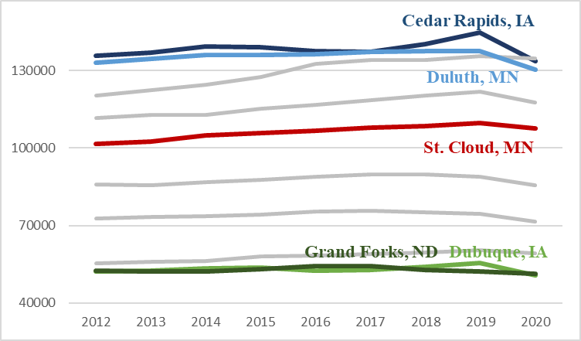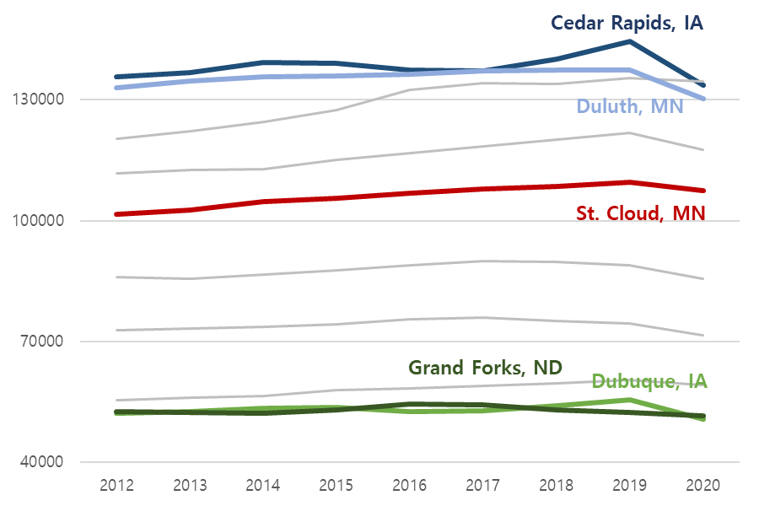

Figure 11

The total employment of St. Cloud is around the average since the number of significantly greater cities are about the same as the number of significantly less cities.

|  |  |  |  |  |  |  |
| --- | --- | --- | --- | --- | --- | --- |
| **(DTK)** | 2017 | | 2018 | | 2019 | |
| **Duluth, MN** | | **+1\*** | | **+1\*** | | **+1\*** | |
| Cedar Rapids, IA | | -2 | | -2* | | -4* | |
| Eau Claire, WI | | -3* | | -3* | | +2 | |
| **Dubuque, IA** | | **-4\*** | | **-7\*** | | **-8\*** | |
| **La Crosse, MN** | | **-5\*** | | **-5\*** | | **-3\*** | |
| **Rochester, MN** | | **-6\*** | | **-6\*** | | **-5\*** | |
| **Mankato, MN** | | **-8\*** | | **-8\*** | | **-7\*** | |
| **Grand Forks, ND** | | **-7\*** | | **-4\*** | | **-6\*** | |
| **Fargo, ND** | | **-9\*** | | **-9\*** | | **-9\*** | |

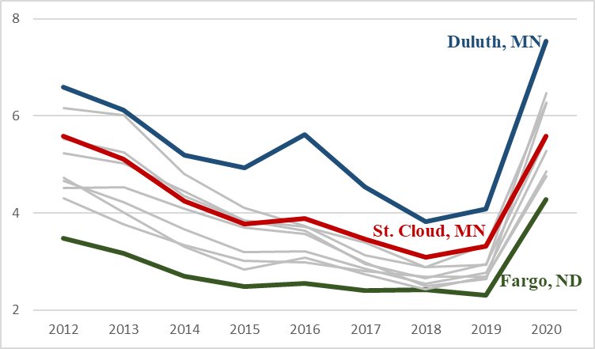Unemployment Rate

Table 12

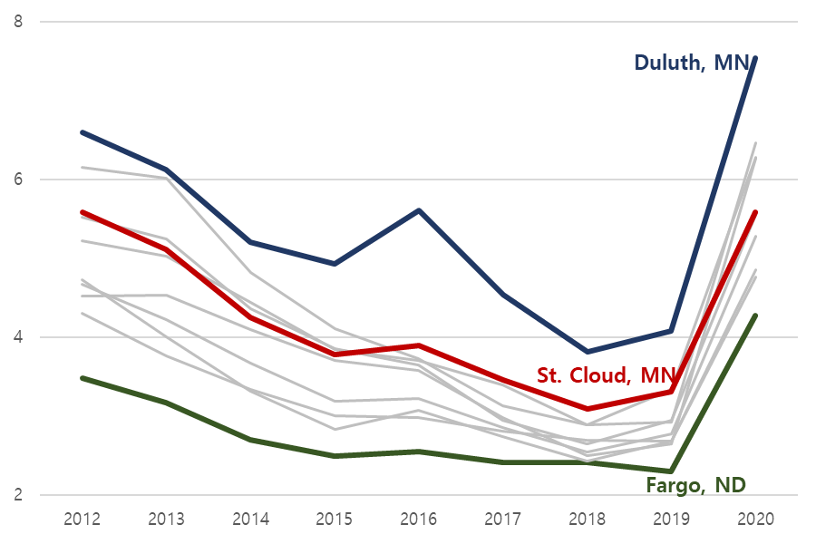

Figure 12

The unemployment rate of St. Cloud is one of the highest since it is significantly greater than the most cities. It is significantly less than Duluth, MN.

* + Summary

In comparison to other 9 Upper Midwest cities, St. Cloud has competitive characteristics of low to average gross rent and one of the lowest population age. Its unfavorable characteristics are one of the highest first mortgage payment and house values, and one of the lowest proportions of finished some college population. Some of the questionable characteristics are high to average family size, the highest travel time to work, one of the highest unemployment rates, and average total employment and civilian labor force participation.

* Occupations
  + Major class

Architecture and Engineering

|  |  |  |  |  |
| --- | --- | --- | --- | --- |
|  | 2017 | 2018 | 2019 | 2020 |
| Ratio | 0.01562 | 0.01562 | 0.04688 | 0.125 |
| Wage | 0.01562 | 0.03125 | 0.01562 | 0.03125 |

Table 13

Figure 133

Figure 144

\The job ratio of Architecture and Engineering occupations in St. Cloud was the lowest, then it had a sharp increase in 2020. The wage of these occupations in St. Cloud is one of the lowest.

|  |  |  |  |  |
| --- | --- | --- | --- | --- |
|  | 2017 | 2018 | 2019 | 2020 |
| Ratio | 0.03125 | 0.01562 | 0.04688 | 0.2812 |
| Wage |  |  |  |  |

Life, Physical, and Social Science

Table 14

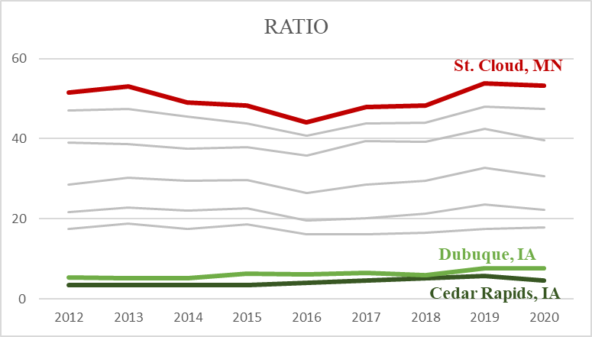

Figure 15

The job ratio of Life, Physical, and Social Science occupations in St. Cloud was the highest.

Community and Social Services

|  |  |  |  |  |
| --- | --- | --- | --- | --- |
|  | 2017 | 2018 | 2019 | 2020 |
| Ratio | 0.03125 | 0.09375 | 0.03125 | 0.01562 |
| Wage | 0.09375 | 0.04688 | 0.01562 | 0.01562 |

Table 15

Figure 166

Figure 177

The job ratio of Community and Social Services occupations in St. Cloud was one of the lowest, but its wage was one of the highest.

Protective Service

|  |  |  |  |  |
| --- | --- | --- | --- | --- |
|  | 2017 | 2018 | 2019 | 2020 |
| Ratio | 0.01562 | 0.01562 | 0.01562 | 0.09375 |
| Wage | 0.01562 | 0.01562 | 0.01562 | 0.1719 |

Table 16

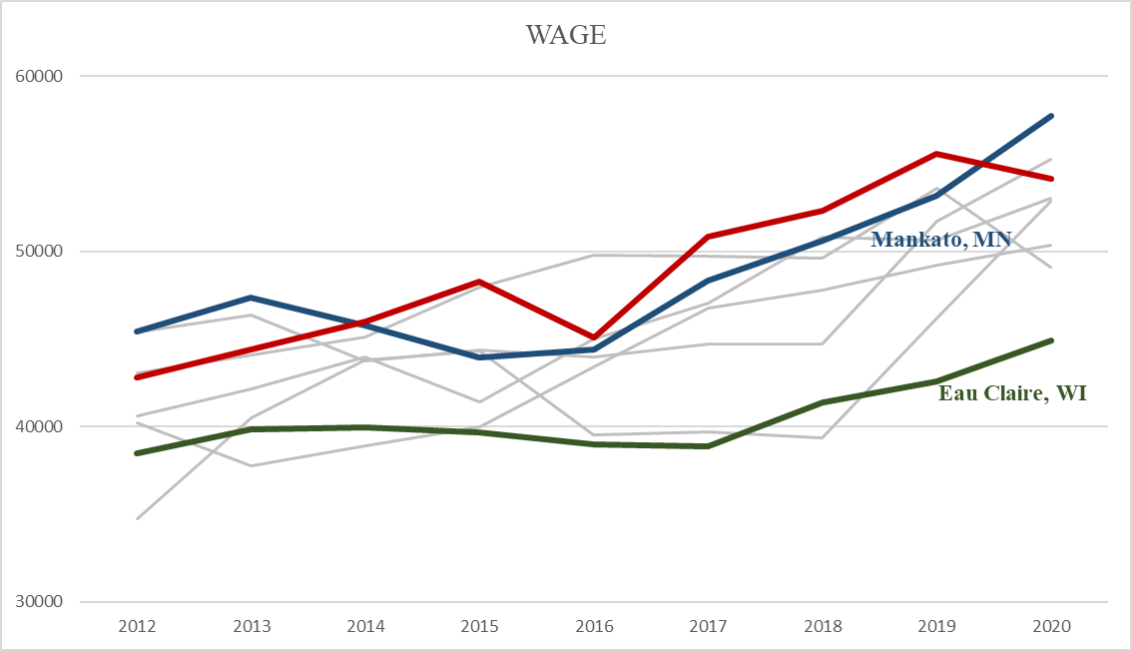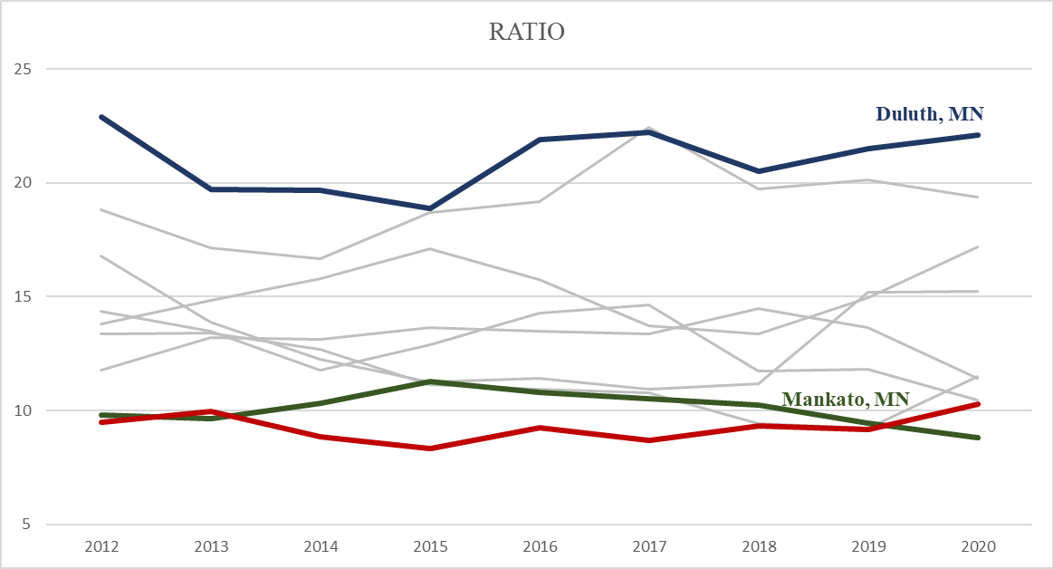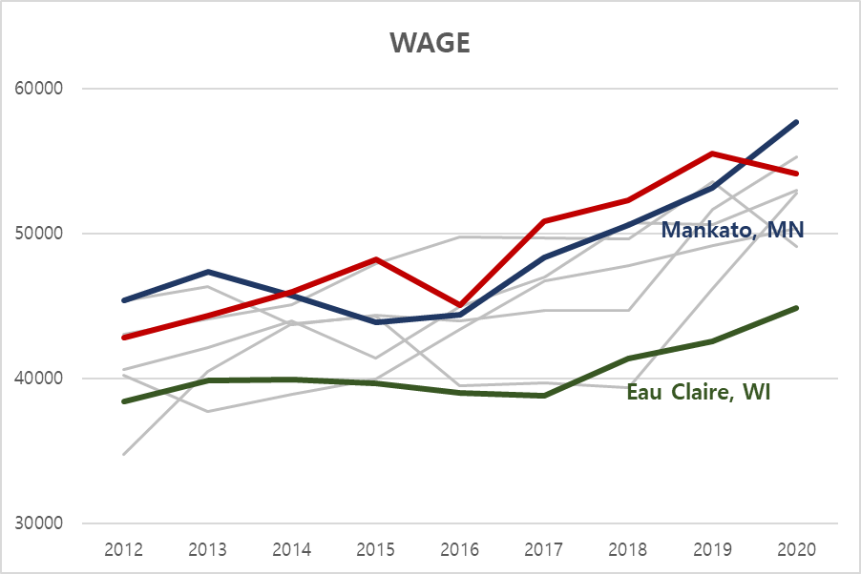

Figure 180

Figure 18

The job ratio of Protective Service occupations in St. Cloud was one of the lowest with a slight increase in 2020, but its wage was one of the highest with a slight decrease in 2020.

Food Preparation and Servicing Related

|  |  |  |  |  |
| --- | --- | --- | --- | --- |
|  | 2017 | 2018 | 2019 | 2020 |
| Ratio | 0.125 | 0.01562 | 0.01562 | 0.01562 |
| Wage | 0.01562 | 0.01562 | 0.03125 | 0.0625 |

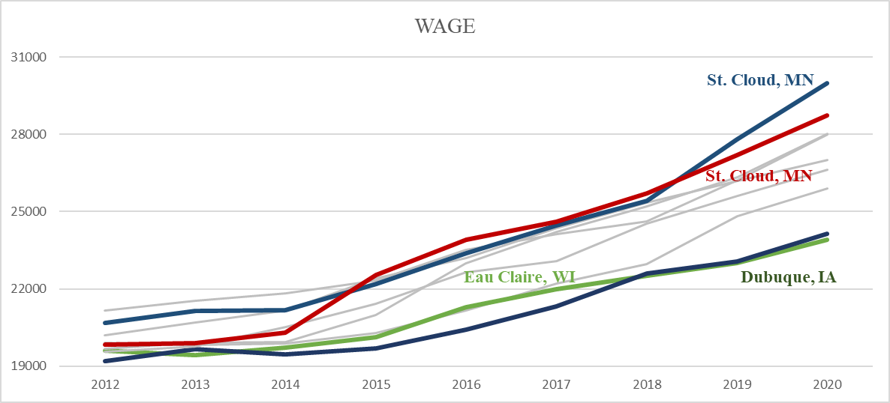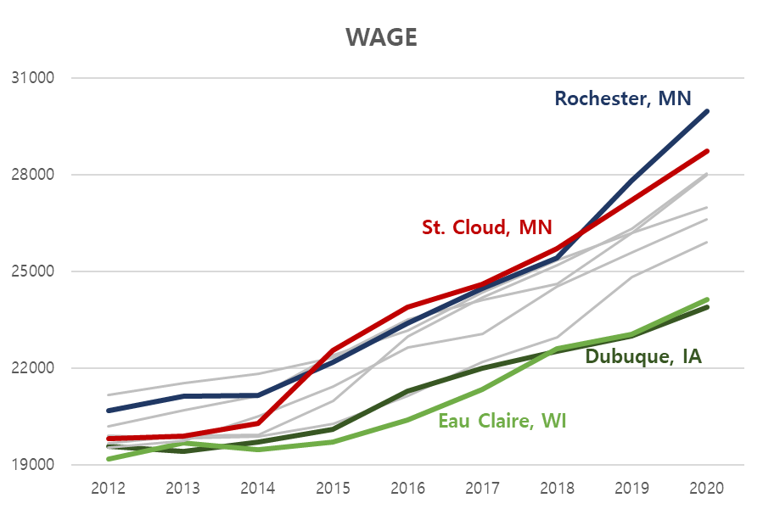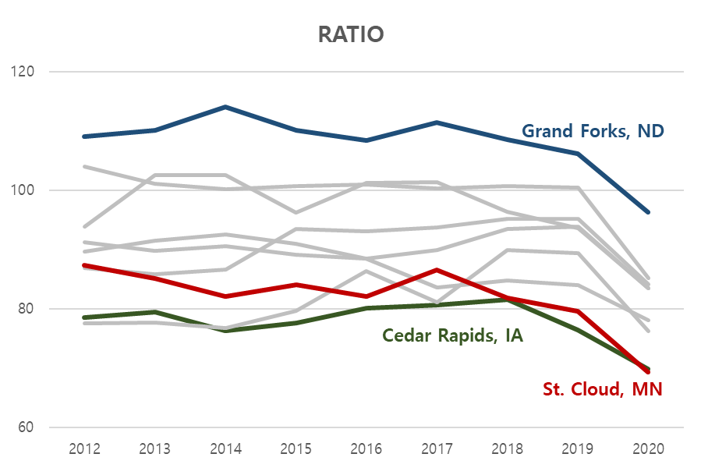Table 17

Figure 19

Figure 20

The job ratio of Food Preparation and Servicing Related occupations in St. Cloud was one of the lowest, but its wage was one of the highest.

Building and Grounds Cleaning and Maintenance

|  |  |  |  |  |
| --- | --- | --- | --- | --- |
|  | 2017 | 2018 | 2019 | 2020 |
| Ratio |  |  |  |  |
| Wage | 0.03125 | 0.01562 | 0.01562 | 0.01562 |

Table 18

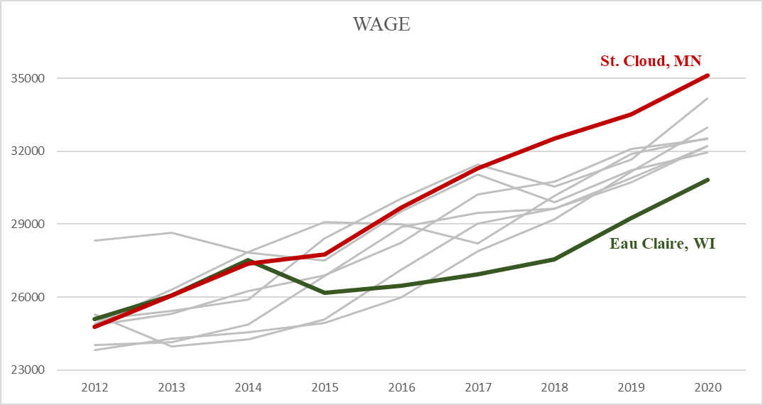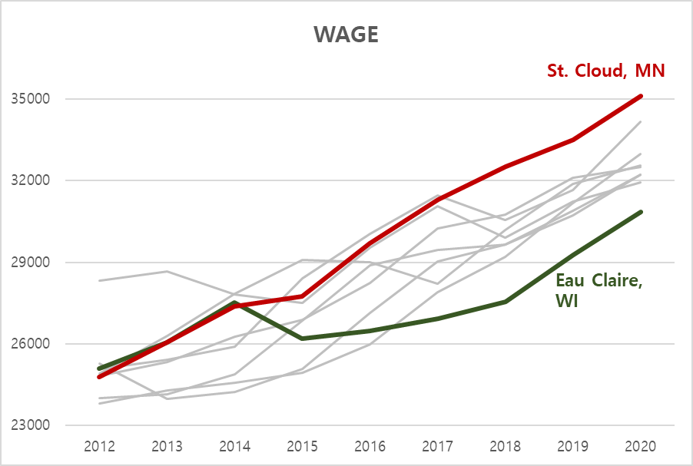

Figure 21

The wage of Building and Grounds Cleaning and Maintenance occupations in St. Cloud was the highest.

Construction and Extraction

|  |  |  |  |  |
| --- | --- | --- | --- | --- |
|  | 2017 | 2018 | 2019 | 2020 |
| Ratio | 0.09375 | 0.04688 | 0.03125 | 0.1719 |
| Wage |  |  |  |  |

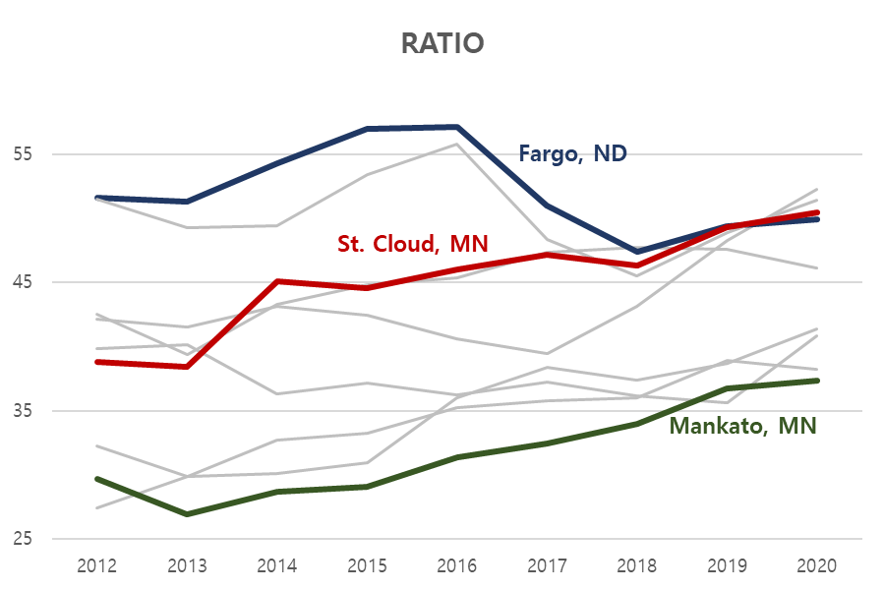Table 19

Figure 22

The job ratio of Construction and Extraction occupations in St. Cloud was one of the highest.

Installation, Maintenance, and Repair

|  |  |  |  |  |
| --- | --- | --- | --- | --- |
|  | 2017 | 2018 | 2019 | 2020 |
| Ratio |  |  |  |  |
| Wage | 0.03125 | 0.01562 | 0.03125 | 0.04688 |

Table 20

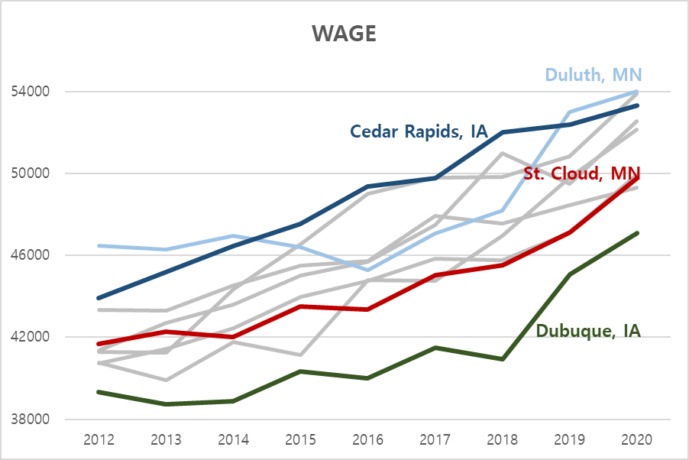

Figure 23

The wage of Installation, Maintenance, and Repair occupations in St. Cloud was one of the lowest.

Production

|  |  |  |  |  |
| --- | --- | --- | --- | --- |
|  | 2017 | 2018 | 2019 | 2020 |
| Ratio | 0.01562 | 0.01562 | 0.01562 | 0.01562 |
| Wage |  |  |  |  |

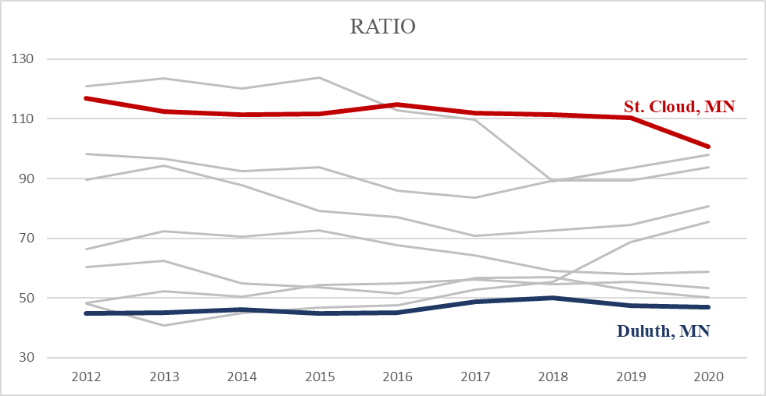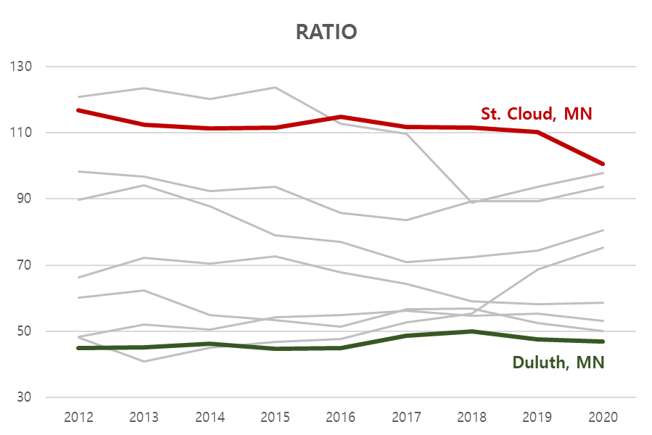Table 21

Figure 24

The job ratio of Production occupations in St. Cloud was the highest.

Transportation and Material Moving

|  |  |  |  |  |
| --- | --- | --- | --- | --- |
|  | 2017 | 2018 | 2019 | 2020 |
| Ratio | 0.01562 | 0.03125 | 0.01562 | 0.03125 |
| Wage |  |  |  |  |

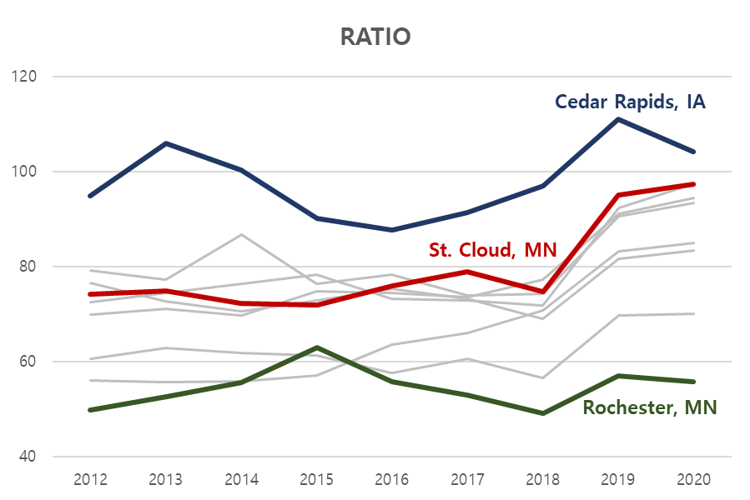Table 22

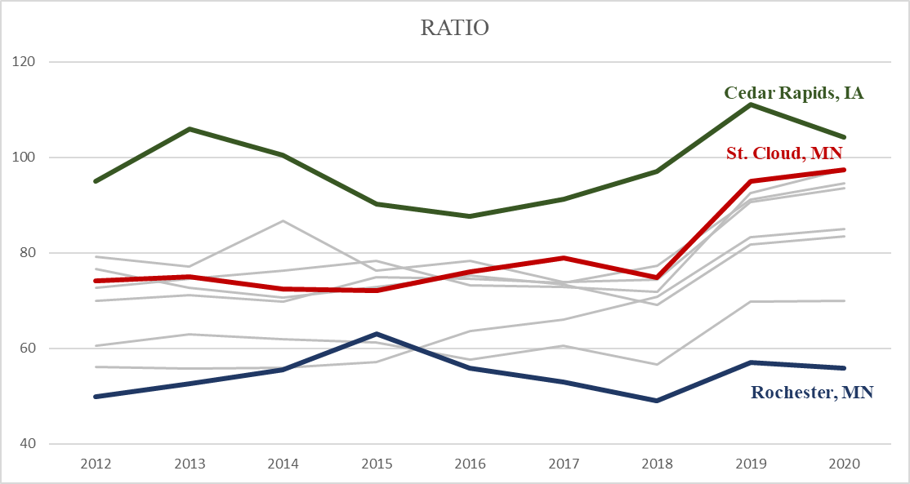

Figure 25

The job ratio of Transportation and Material Moving occupations in St. Cloud was the second highest.

* + Subclass

The significant subclasses with low quotient are: First-Line Supervisors of Transportation & Material Moving Workers (except aircraft cargo handling supervisors) and Landscaping and Groundskeeping Workers.

The significant subclasses with high quotient are: Bartenders, Heavy and Tractor-Trailer Truck Drivers, Licensed Practical & Vocational Nurses, Operating Engineers & Other Construction Equipment Operators, Plumbers, Pipefitters, & Steamfitters, and Welders, Cutters, Solderers, & Brazers.

First-Line Supervisors of Transportation & Material Moving Workers (except aircraft cargo handling supervisors) – Under Protective Service

|  |  |  |  |  |
| --- | --- | --- | --- | --- |
|  | 2017 | 2018 | 2019 | 2020 |
| Ratio |  |  |  |  |
| Wage | 0.01562 | 0.01562 | 0.04688 | 0.1719 |

Table 23

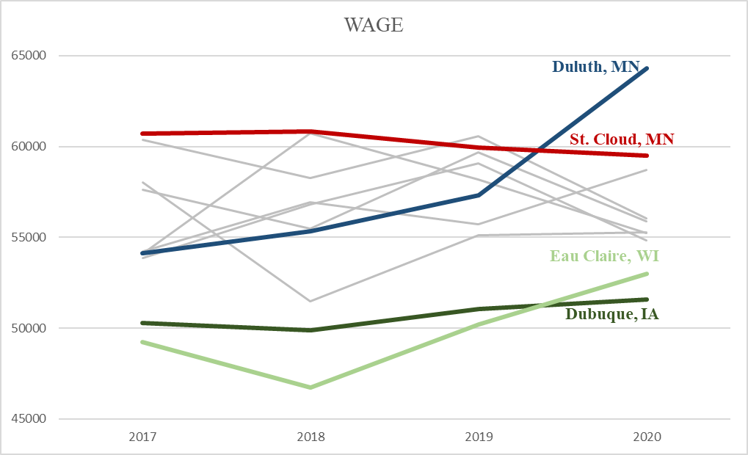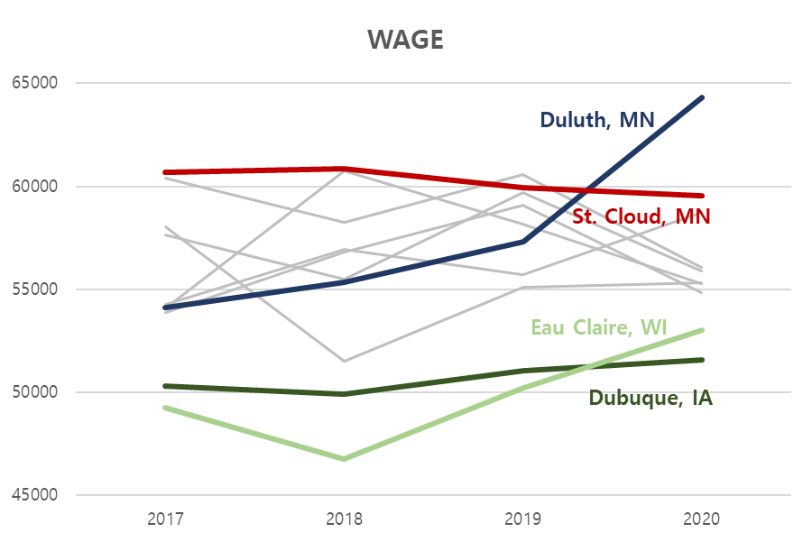

Figure 26

The wage of First-Line Supervisors of Transportation & Material Moving Workers (except aircraft cargo handling supervisors) occupations in St. Cloud was one of the highest. It is slightly decreasing.

|  |  |  |  |  |
| --- | --- | --- | --- | --- |
|  | 2017 | 2018 | 2019 | 2020 |
| Ratio | 0.01562 | 0.01562 | 0.09375 | 0.01562 |
| Wage | 0.4219 | 0.2812 | 0.01562 | 0.01562 |

Landscaping and Groundskeeping Workers – Under Building and Grounds Cleaning and Maintenance

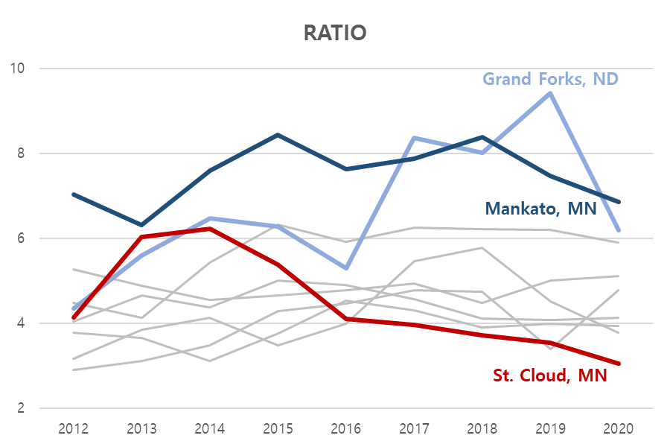Table 24

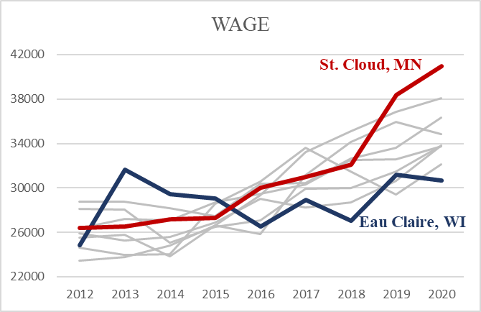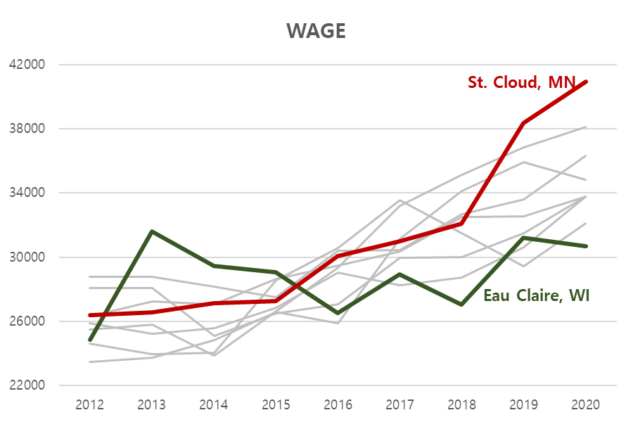

Figure 27

Figure 28

The job ratio of Landscaping and Groundskeeping occupations in St. Cloud was one of the lowest, but its wage was one of the highest with sharp increasing trend.

Bartenders – Under Food Preparation and Servicing Related

|  |  |  |  |  |
| --- | --- | --- | --- | --- |
|  | 2017 | 2018 | 2019 | 2020 |
| Ratio | 0.03125 | 0.01562 | 0.04688 | 0.125 |
| Wage |  |  |  |  |

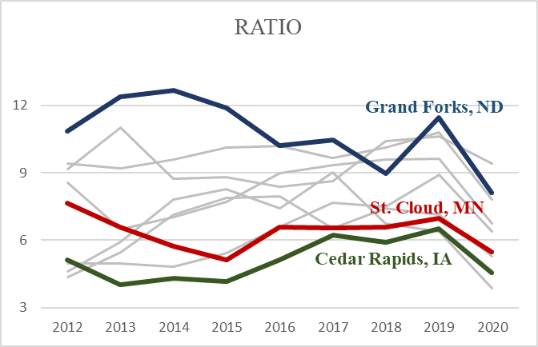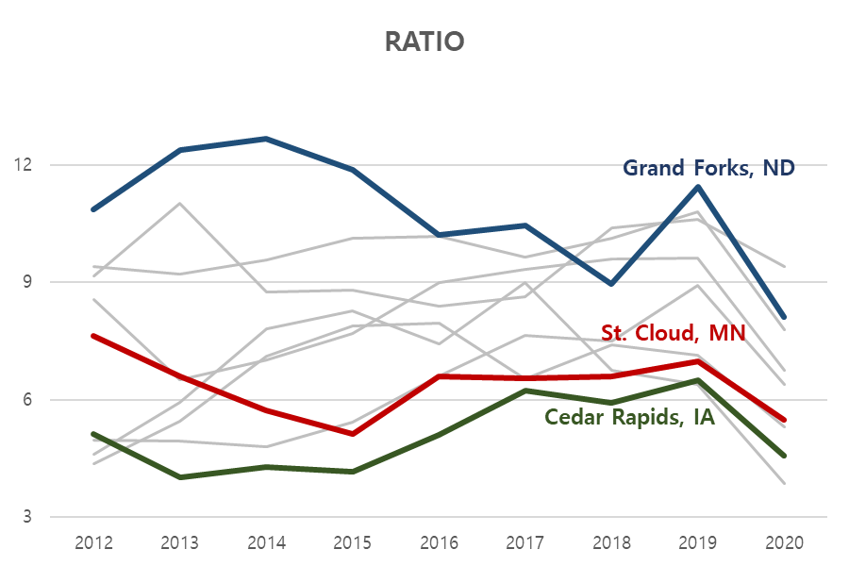Table 25

Figure 29

The job ratio of Bartender occupations in St. Cloud was one of the lowest.

Heavy and Tractor-Trailer Truck Drivers – Under Transportation and Material Moving

|  |  |  |  |  |
| --- | --- | --- | --- | --- |
|  | 2017 | 2018 | 2019 | 2020 |
| Ratio | 0.01562 | 0.04688 | 0.01562 | 0.04688 |
| Wage |  |  |  |  |

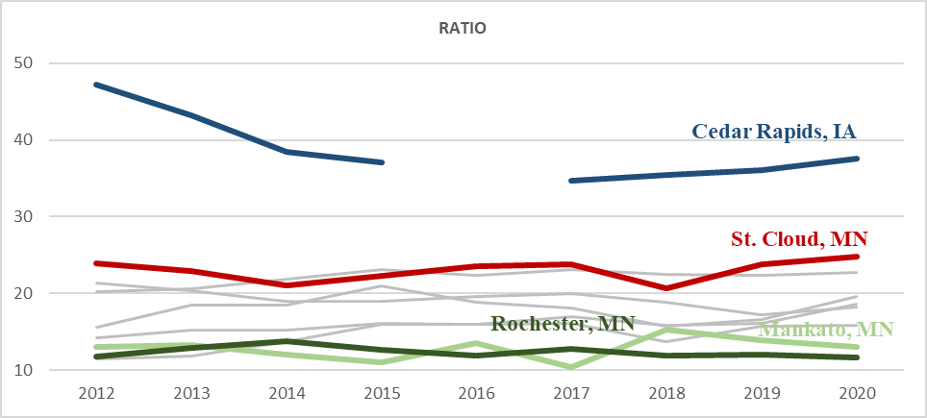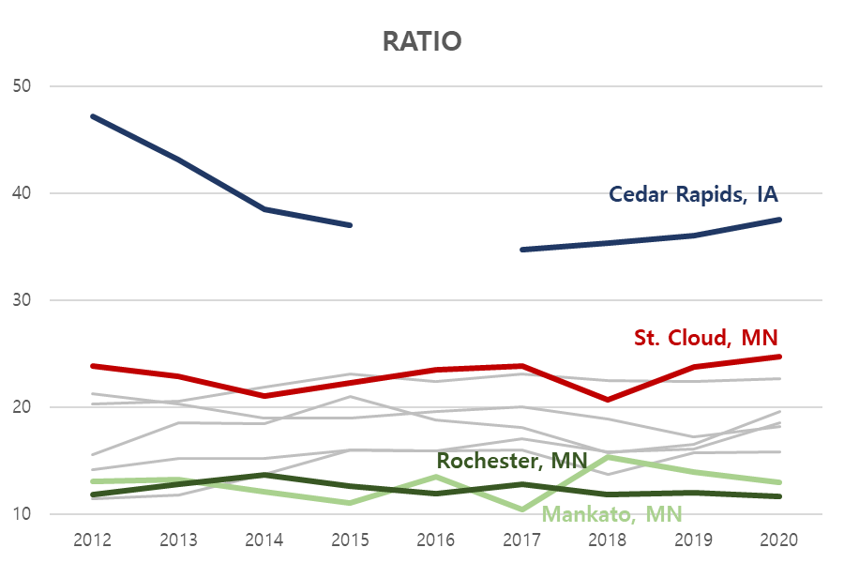Table 26

Figure 30

The job ratio of Heavy and Tractor-Trailer Truck Drivers occupations in St. Cloud was one of the lowest.

|  |  |  |  |  |
| --- | --- | --- | --- | --- |
|  | 2017 | 2018 | 2019 | 2020 |
| Ratio | 0.125 | 0.03125 | 0.0625 | 0.03125 |
| Wage |  |  |  |  |

Licensed Practical & Licensed Vocational Nurses – Under Healthcare Practitioners and Technical

Table 27

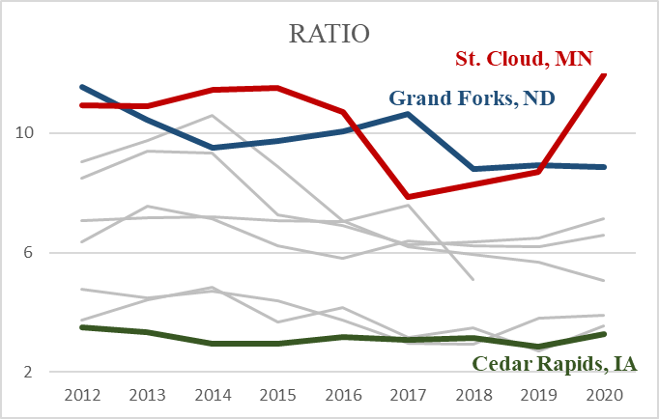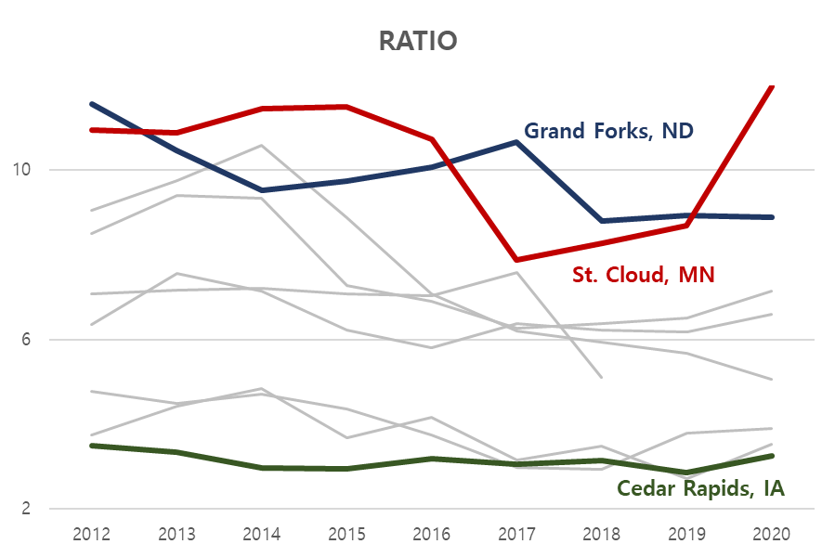

Figure 31

The job ratio of Licensed Practical & Licensed Vocational Nurses occupations in St. Cloud was one of the highest with an increasing trend.

|  |  |  |  |  |
| --- | --- | --- | --- | --- |
|  | 2017 | 2018 | 2019 | 2020 |
| Ratio | 0.01562 | 0.03125 | 0.01562 | 0.09375 |
| Wage |  |  |  |  |

Operating Engineers & Other Construction Equipment Operators – Under Construction and Extraction

Table 28

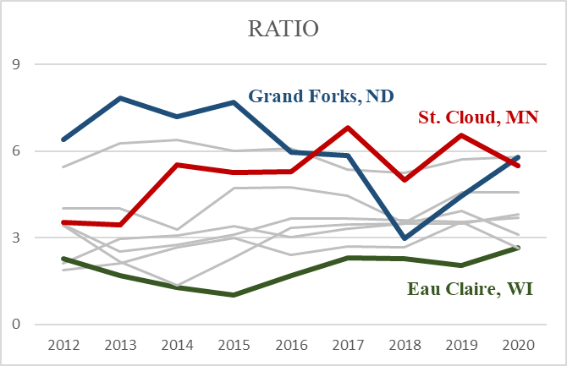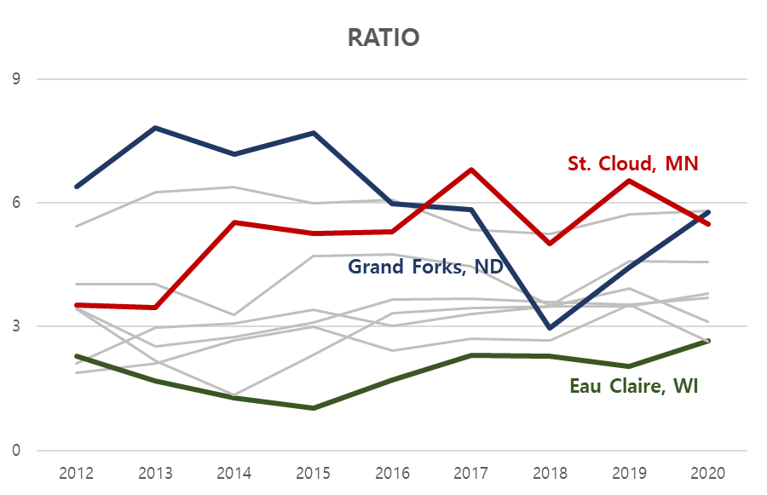

Figure 32

The job ratio of Operating Engineers & Other Construction Equipment Operators occupations in St. Cloud was one of the highest.

|  |  |  |  |  |
| --- | --- | --- | --- | --- |
|  | 2017 | 2018 | 2019 | 2020 |
| Ratio | 0.01562 | 0.01562 | 0.01562 | 0.01562 |
| Wage |  |  |  |  |

Plumbers, Pipefitters, & Steamfitters – Under Construction and Extraction

Table 29

Figure 33

The job ratio Plumbers, Pipefitters, & Steamfitters occupations in St. Cloud was one of the highest.

Welders, Cutters, Solderers, & Brazers

|  |  |  |  |  |
| --- | --- | --- | --- | --- |
|  | 2017 | 2018 | 2019 | 2020 |
| Ratio | 0.01562 | 0.01562 | 0.01562 | 0.01562 |
| Wage |  |  |  |  |

Table 30

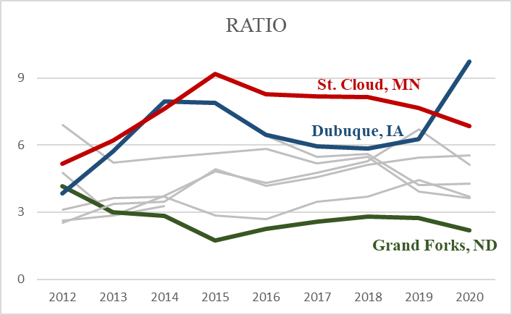

Figure 34

The job ratio Welders, Cutters, Solderers, & Brazers occupations in St. Cloud was one of the highest with a decreasing trend.

* + Summary

|  |  |  |
| --- | --- | --- |
|  | Job Ratio | Annual Mean Wage |
| High | **Life, Physical, and Social Science** – highest  **Production** – highest  Transportation and Material Moving– second highest  **Construction and Extraction** – 3 high quotients | **Building and Grounds Cleaning and Maintenance**  – highest, 3 low quotients  Protective Service  Community and Social Services  Food Preparation and Servicing Related |
| Low | Protective Service– lowest  Community and Social Services  Food Preparation and Servicing Related | Installation, Maintenance, and Repair  Architecture and Engineering |
| Interesting Pattern | Architecture and Engineering– sharp increase |  |

Major Classifications

Noticeable Subclassifications

|  |  |  |
| --- | --- | --- |
|  | Job Ratio | Annual Mean Wage |
| High | **High Quotient**   * Construction and Extraction   Operating Engineers & Other Construction Equipment Operators  Plumbers, Pipefitters, & Steamfitters  Welders, Cutters, Solderers, and Brazers  **Low Quotient**   * Healthcare Practitioners and Technical   Licensed Practical & Licensed Vocational Nurses | **Low Quotient**   * Building and Grounds Cleaning and Maintenance   First-Line Supervisors of Transportation & Material Moving Workers, Except Aircraft Cargo Handling Supervisors  Landscaping and Groundskeeping Workers |
| Low | **High Quotient**   * Transportation and Material Moving   Heavy and Tractor – Trailer Truck Drivers   * Food Preparation and Servicing Related   Bartenders  **Low Quotient**   * Building and Grounds Cleaning and Maintenance   Landscaping and Groundskeeping Workers |  |

# **Conclusion**

To provide EDA with better understanding of St. Cloud’s competitive factors, this study focused on analyzing some of the factors that St. Cloud differs from 9 other comparable Upper Midwest cities. Via some statistical analysis, the following key insights about St. Cloud was revealed:

* High family size with the lowest population age and low college education attainment.
* High house and mortgage values but log rent.
* The highest travel time to work.
* The highest unemployment rates.
* Low number with high wage jobs in protective services, community and social services, food preparation and servicing related, and landscaping and groundskeeping workers.
* Sharp increase in number of jobs in architecture and engineering, but with low wage.
* High number of jobs in industrial manual labors, specifically in construction and extractions, production, transportation and material moving.

The findings may not be directly related to what EDA is looking to promote in their marketing of business establishments. Although, the given insights provide EDA some direction of which areas they need to look into for the future researches.

# **Limitations**

First and foremost, the definition of city’s geographical perimeter is not consistent. Especially for IPUMS data, its PUMA approximation for the cities only includes one major county that the city lies on. Therefore, there can be some missing information in the statistics.

Secondly, due to the complexity of DTK’s set up, the control of error rate is hard to interpret. Compared to HSD, DTK is more likely to return significant results, therefore, there may be some misleading information for the statistical testing.

Lastly, the statistical testing only includes the past couple years and not all time periods given. This may give biased result if there was a large change in the recent years.

# **Future work**

From the key insights, the following topics may be considered for the future work:

* Why is travel time to work in St. Cloud so high?

Is it due to better job opportunities in the twin cities? Where do people go to work?

* What causes high employment rate in St. Cloud?

Is it due to the lack of job opportunities or due to the unwillingness to work?

* Why is the college education attainment is so low in St. Cloud?

St. Cloud has the lowest population age but also the low college graduate proportions.

* Why some occupations have low number of jobs but high wage?

Protective Service, Community and Social Services, Food Preparation and Servicing Related, Landscaping and Groundskeeping Workers have low number of jobs with high wage.

* What happened to Architecture and Engineering industry in MN?

There is a sharp increase in the number of jobs for Architecture and Engineering in St. Cloud where there was a sudden drop of its wage in Rochester, MN.

* What sources high number of manual labor jobs in St. Cloud?

St. Cloud has high number of manual labor jobs.

# **Appendix**

* **Appendix A**: Chosen Variables

IPUMS: Household and Personal Income, Family Size, First Mortgage Payment, Gross Rent, Travel Time to Work, Value of House, Age, Usual Hours per Week, Available to Work, Available and Looking to Work, Proportion of population that finished up to high school, Proportion of population that finished some college

OEWS Low Quotient: Accountants and Auditors, Computer and Information Systems Managers, Computer Systems Analysts, First-Line Supervisors of Transportation and Material Moving Workers, Except Aircraft Cargo Handling Supervisors, Landscaping and Groundskeeping Workers, Lawyers, Management Analysts, Market Research Analysts and Marketing Specialists, Medical Assistants, Paralegals and Legal Assistants

OEWS High Quotient: Bartenders, Bus and Truck Mechanics and Diesel Engine Specialists, Cabinetmakers and Bench Carpenters, Credit Analysts, Food Batchmakers, Heavy and Tractor-Trailer Truck Drivers, Library Assistants, Clerical, Licensed Practical and Licensed Vocational Nurses, Mobile Heavy Equipment Mechanics, Except Engines, Operating Engineers and Other Construction Equipment Operators, Ophthalmic Laboratory Technicians, Plumbers, Pipefitters, and Steamfitters, Print Binding and Finishing Workers, Printing Press Operators, Separating, Filtering, Clarifying, Precipitating, and Still Machine Setters, Operators, and Tenders, Special Education Teachers, Secondary School, Telecommunications Line Installers and Repairers, Welders, Cutters, Solderers, and Brazers, Woodworking Machine Setters, Operators, and Tenders, Except Sawing

* **Appendix B**: Full Testing Results & R Code

The full testing results and the coding is found in RPub link below:

<https://rpubs.com/haneumlee99/767614>

# **References**

**Steven Ruggles, Sarah Flood, Sophia Foster, Ronald Goeken, Jose Pacas, Megan Schouweiler and Matthew Sobek. *IPUMS USA: Version 11.0* [dataset]. Minneapolis, MN: IPUMS, 2021.**   
<https://doi.org/10.18128/D010.V11.0>

“Smoothed Seasonally Adjusted Metropolitan Area Estimates.” *U.S. Bureau of Labor Statistics*, U.S. Bureau of Labor Statistics, 16 Apr. 2021.

www.bls.gov/lau/metrossa.htm.

“Tables Created by BLS.” *U.S. Bureau of Labor Statistics*, U.S. Bureau of Labor Statistics, 31 Mar. 2021.

www.bls.gov/oes/tables.htm.